Frogger Reloaded: User Guide

*So you want to play the hit new game Frogger Reloaded? Read on for tips and tricks from the pros!*

Story

Frogger, an ordinary frog, wants to see the world. Though the world is teeming with danger of all kinds, it’s worth it to see what the horizon holds!

Starting the Game

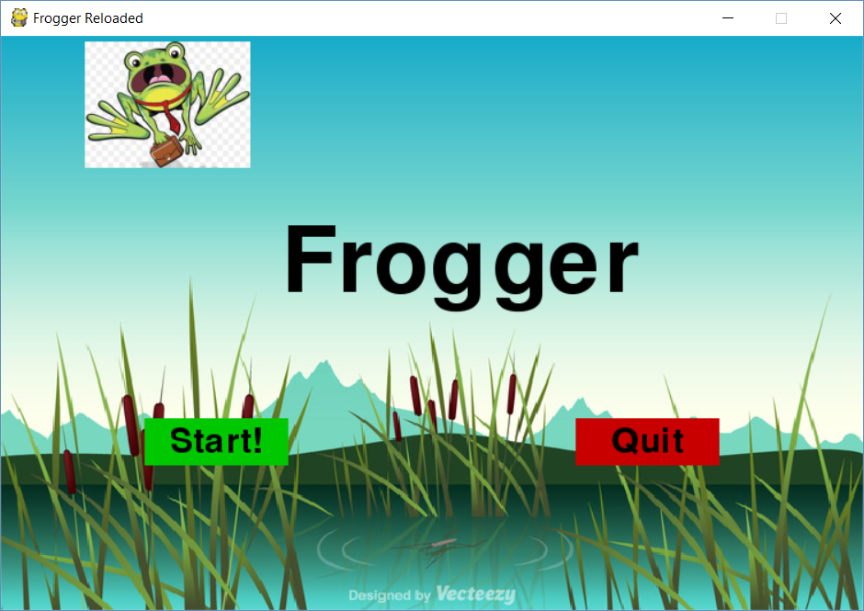

When you start the game, you will see the title screen. To start the game, click the start button. To stop playing, click the Quit button.

Controls

Here’s a list of controls for the game.

|  |  |
| --- | --- |
| **Control** | **Function** |
| Up Arrow | Moves Frogger up |
| Down Arrow | Moves Frogger down |
| Right Arrow | Moves Frogger right |
| Left Arrow | Moves Frogger left |
| Spacebar | Fire a projectile upwards (only in fly invaders mode) |

Scoring and Gameplay Synopsis

In the game, there are different stages. A stage can be completed by moving Frogger to the top of the screen, and pushing the up arrow. This causes Frogger to move into the next stage, and increase his score by one. The score is displayed in the bottom right-hand side of the screen.

Basic Stage

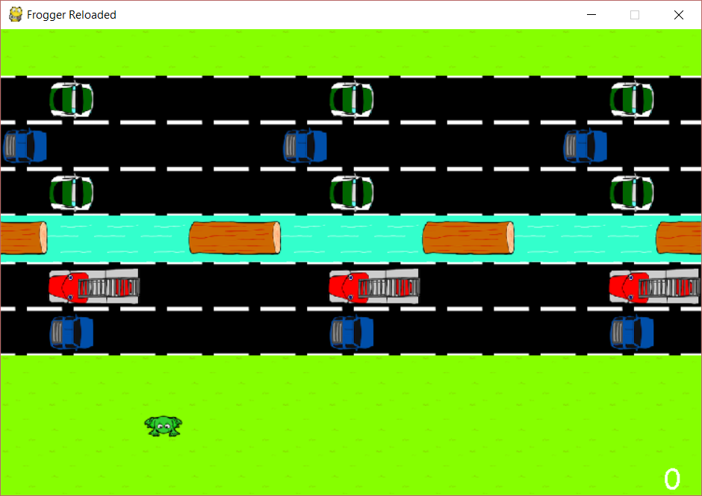

In the stage most similar to the original game, Frogger must navigate a series of obstacles in order to complete it. However, there’s a catch: every time that this stage generates, it is entirely new! Sometimes it will be quite simple, and sometimes it will be almost impossible. That’s life!

Cars may come from either side of the screen on roads. If Frogger gets run over by a car, he will die.

If Frogger jumps into the swamp, he will die. How will he get across? By hitching a ride on one of the floating log platforms. Just make sure to get off before the edge of the screen!

**Protip:** Wise frogs know that getting through a basic stage is all about timing. Try to memorize the pattern, and plan your way across before starting.

Fly Invaders

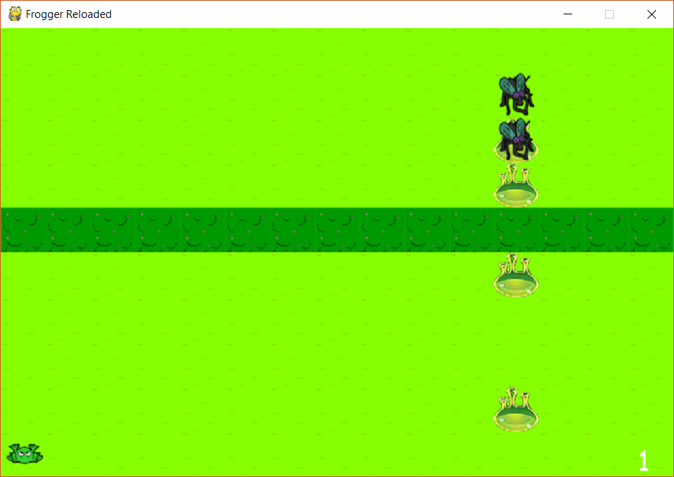

In this stage, flies attempt to stop you with their goo! Flies may move horizontally or vertically, and will periodically fire projectiles downward. If one of these hit you, it’s game over! However, you have the ability to fight back. Press the spacebar to fire back. Once all of the flies have been defeated, the bush will disappear, allowing you to progress to the next stage.

**Protip:** Try to predict enemy movements so you can lead your shots.

Lake

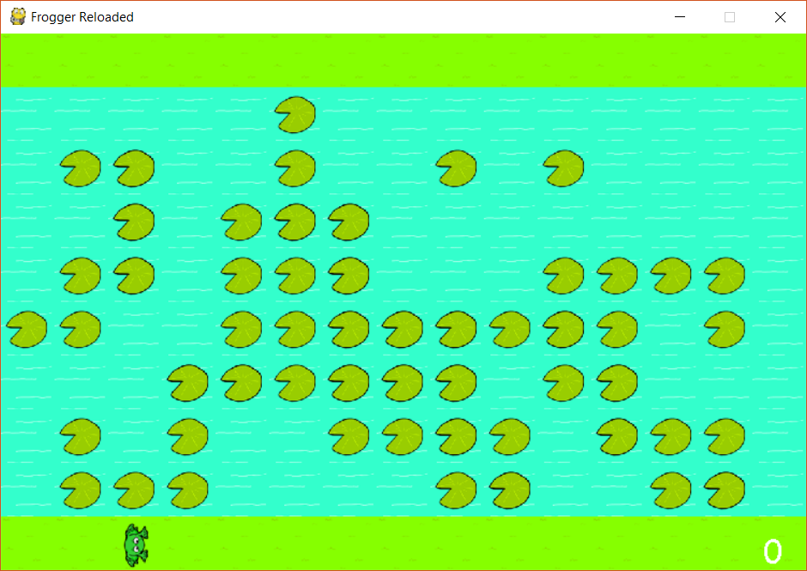

There is a lake in the way. What ever will you do? Luckily, there are some lily pads forming a bridge across. There’s a catch - once you walk on a lily pad, it will sink! Therefore, there is no way back.

Game Over

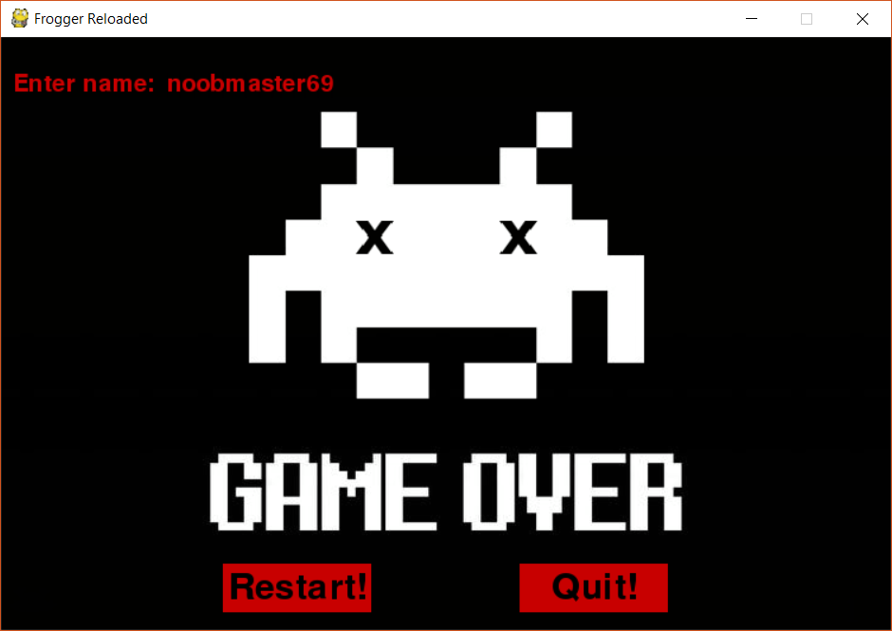

When you die, you will be taken to the game over screen. A prompt will tell you to enter your name. Once you enter your name, hit enter to see how you rank amongst the high scorers!

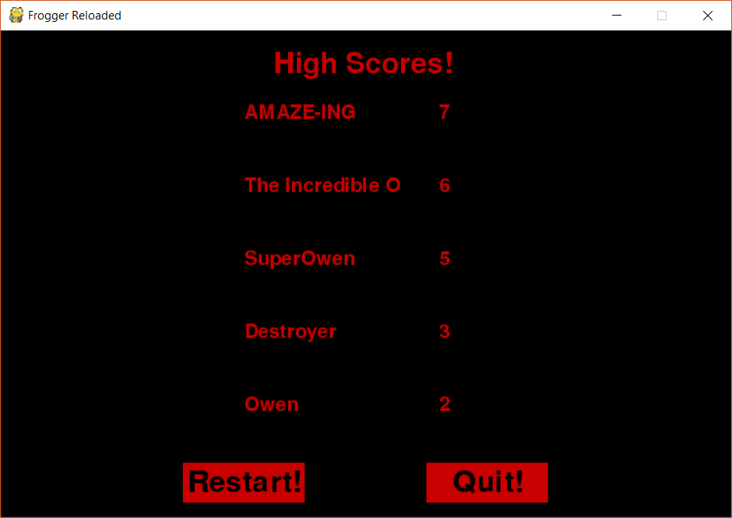

Click the Restart button to return to the main menu, and the Quit button to quit.

Good Luck!

It’s a wide, wild world out there, Frogger! Stay safe, and look both ways before you cross the street. :)